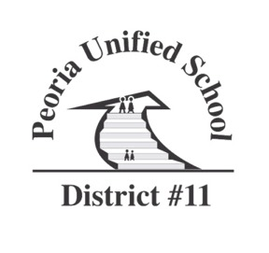

PUBLIC NOTICE

Notice is hereby given to members of Peoria Site Council will participate in a council meeting.
The purpose of the Site Council is to review curriculum, budget, school site issues and make recommendations to school administration.

The meeting will be: Peoria Elementary Site Council
August 31, 2022
5:30 PM
Peoria Elementary Library

The agenda is as follows:

- Call to Order – Welcome

- Topics
  - Site Council By-Laws
    - Overview
    - Member voting

  - Tax Credits:
    - Possible funding needs: shade, uniforms, instruments, gardening club, field marker machine & paint for sports
    - Approval for sending Greatest Needs money

  - Campus Updates:
    - What are the needs?
    - Community partnerships

  - Title I and Federal Funding information

  - Request for Future Topics

- Adjournment

Copies of the minutes will be available at the office of Peoria Elementary one week after the meeting.

Date Posted: 8/24/22 Time Posted: 11:00 AM Posted by: B. LoPresto

Persons with a disability may request a reasonable accommodation, such as an interpreter, by contacting 623-412-4450.

The Peoria Elementary Site Council will hold regularly scheduled meetings for this school year on the following dates: 8/31/22, 10/27/22, 1/26/23, 3/30/23. Additional meetings as needed.

